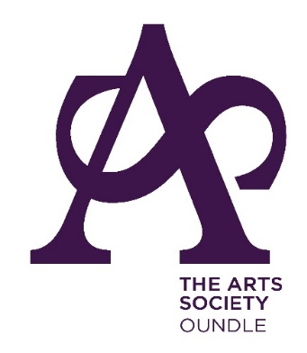
THE ARTS SOCIETY OUNDLE
Minutes of the Annual General Meeting
Held on 14th September 2020 at 11:00 am

Due to Covid restrictions the AGM has had to be held via e-mail and postal delivery (for those not on e-mail). Formal notice sent by post was given to all members with the statutory 35 days’ notice.
- APOLOGIES FOR ABSENCE – not applicable
- THE MINUTES OF THE AGM HELD ON 20th SEPTEMBER 2019
The minutes had been circulated to members prior to the AGM. As no objections or comments had been received, the minutes were approved. The minutes were signed by the Chair.
- MATTERS ARISING
There were no matters arising.
- ANNUAL ACCOUNTS OF THE SOCIETY AND THE TREASURER’S REPORT
The accounts and treasurer’s report had been made available to all members prior to the AGM. As no objections or comments had been received the accounts were approved.
- ELECTION OF FINANCIAL EXAMINER OF THE ACCOUNTS
Bryn Smart had been proposed as the new independent Financial Examiner. This appointment was approved.
- COMMITTEE REPORT ON THE ACTIVITIES IN 2019-2020
All the Committee reports had been posted on the website.
- TO CONSIDER ANY RESOLUTIONS FOR WHICH DUE NOTICE HAS BEEN GIVEN
No resolutions had been received.
- ELECTION OF OFFICERS
The Committee was sad to see the resignation of Barney Broadbent who had had responsibility for Special Projects and who had been a valued member. There has as yet been no volunteer to replace Barney. The Committee were very pleased to have a new Arts in the Community representative – Jackie Leesons – who has come into the role in very challenging times.
The following Officers of the Committee agreed to serve for the following year to maintain continuity, if the members so wished:
Nigel Harper as Chair and Church Recording
Lidia Douglas as Honorary Secretary
Stefan Pijanowski as Honorary Treasurer and IT Consultant

Tony Batchelor as Membership Secretary
Gunta Krumins and Erica Kendall as Programme Planners
Sandy Cooke and Charles Cornford as Events Secretaries
Chris Cooke who will be dealing with Church Trails
Jackie Leesons as Arts in the Community
Special Projects - pending
As no objections had been received, all the above members were re-elected.
- ANY OTHER BUSINESS
There was no other business

Signed: Nigel Harper

Dated: 14.09.2020

