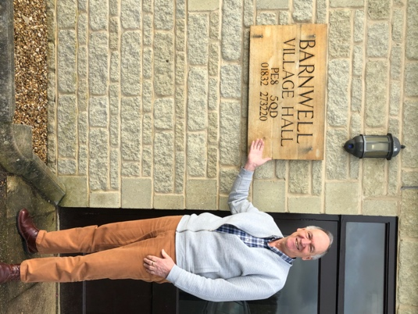
What exciting but worrying times we are living through! As Chairman I never thought I would be reporting on the cancellation of the last four lectures, not to mention a Study Day, of our 2019/20 season. We hope, where possible, to include them in a future programme.
The Arts Society Oundle
Newsletter 2019 - 2020

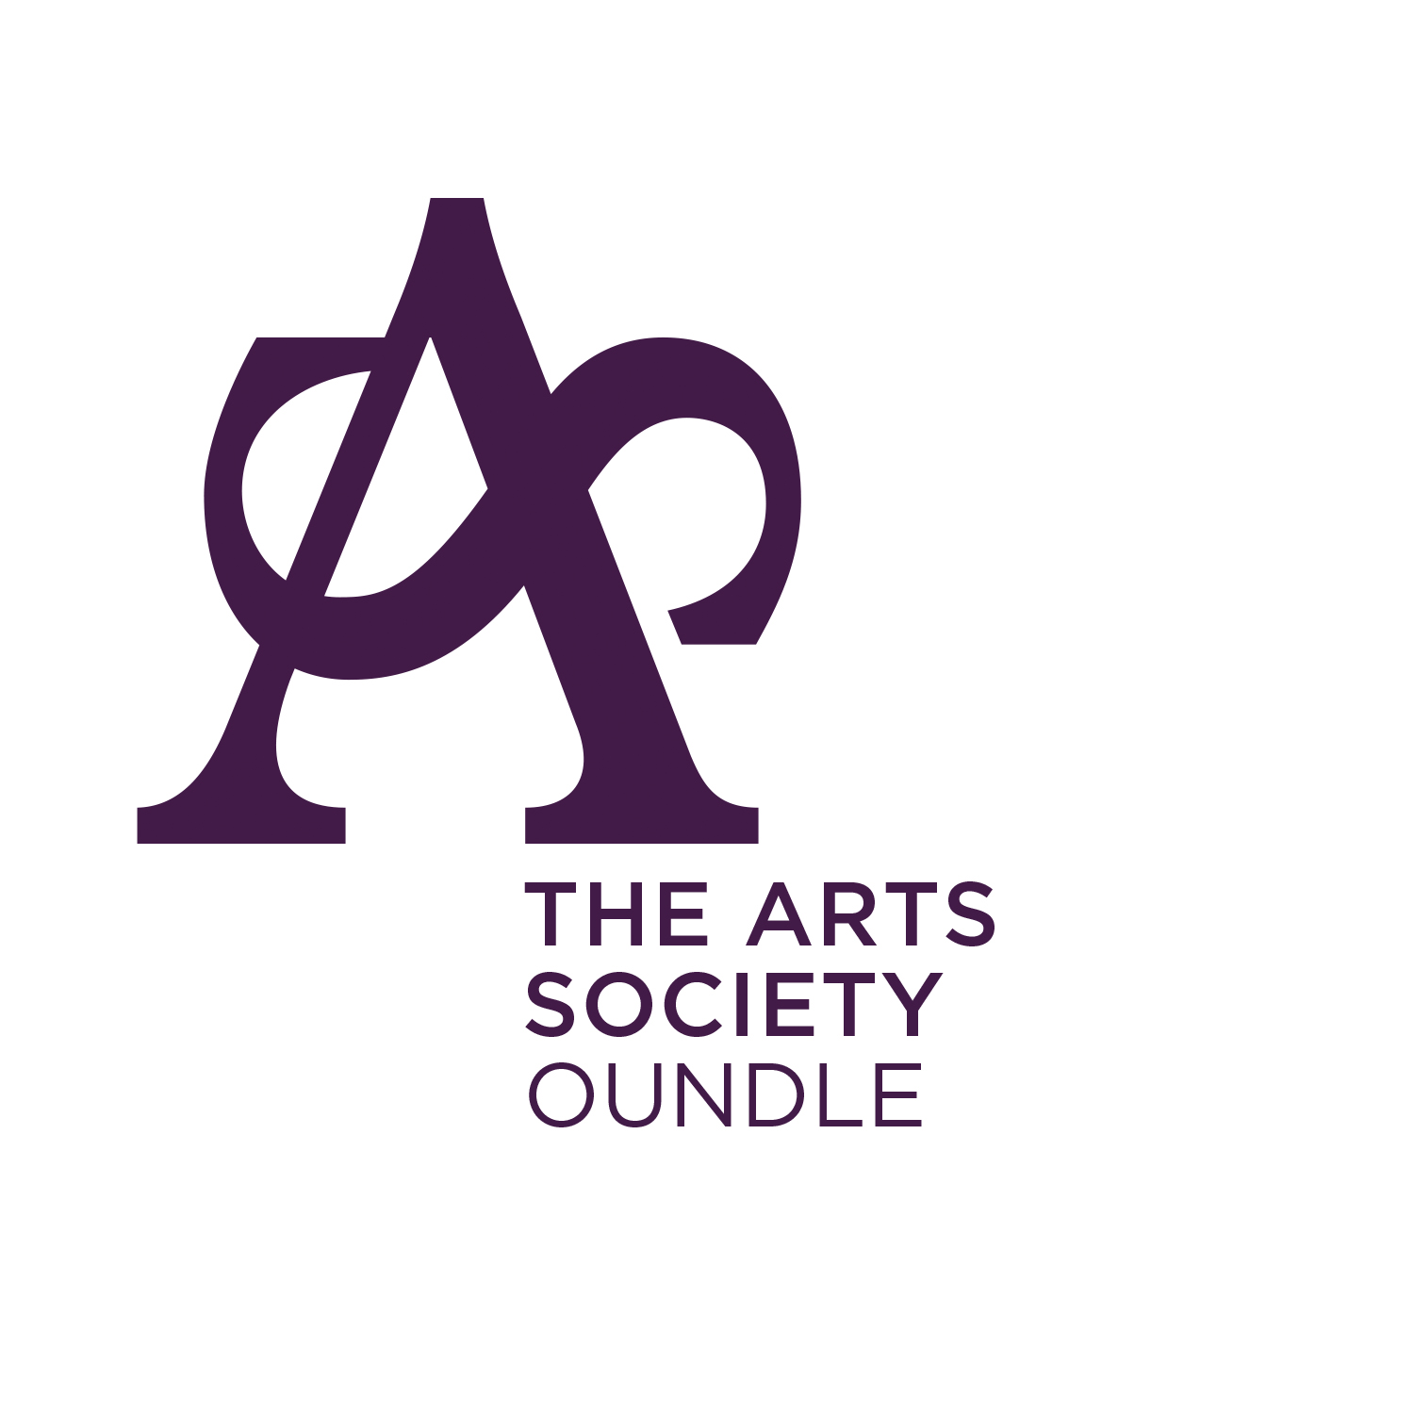
In these exceptional circumstances our main concern, of course, is for the safety and well-being of our members. What I can promise you is that we will keep you informed of all developments, especially in connection with our 2020/21 season. This Website Newsletter is a first so we will be interested in your reactions to it. Our website, of course, is also new and should serve as a valuable source of information about us as a Society.
Nigel Harper – Chairman

Committee Update – Nigel Harper

Following the retirement from the Committee of Carol Ankers, whom I thanked in the last Newsletter, we are delighted to welcome Jackie Leesons as our new Arts in the Community Secretary. Her first report is in this Newsletter. We are saying goodbye to Barney Broadbent, our Special Events Secretary, who has resigned from the Committee with immediate effect. We will miss his valuable contribution to our discussions, always asking the sort of questions which moved us on when we needed to. My thanks to Barney, on behalf of the Committee and our members.

Membership Update – Tony Batchelor
I am pleased to report that the Membership remains solid and at the time of writing we have 320 full members and a short waiting list of 14 individuals. Communication with members is a key task for the Membership Secretary and increasingly this is by electronic means. In addition to group emails, we now have our new website, and we encourage members to use it regularly for news, updates and the latest information about meetings and other events. However, we will ensure that those without access to (or interest in!) internet-based communications continue to receive key information through the post.
The committee were all greatly encouraged by the enthusiastic and supportive response to the Chairman’s recent email concerning our future plans. Many of you replied to voice your appreciation for our events and determination not to let our Society fade away. The general feeling was that those who could afford to were happy to continue to fund the Society through the annual subscription, even in the absence of a full programme in the short term. It is good to know how much the Society is valued. The Committee is meeting on Zoom to discuss how we can adapt our events to keep our members safe.

Arts in the Community – Jackie Leesons
I have recently taken over the role of Arts in the Community representative and am looking forward to a time when we can resume the exciting projects that are supported by The Arts Society in Oundle and the surrounding villages.
The 2020 Oundle International Festival and Oundle Festival of Music and Drama have been cancelled due to the coronavirus outbreak. The Society’s support for these festivals will continue in 2021 with an increased donation of £750 to help with mounting running costs.
Oundle Fringe Festival have approached us for a contribution towards their expenses. The Fringe Festival was inaugurated in 2011 to put on a wide range of musical and other cultural events during the International Festival. It is organised by volunteers who coordinate and promote all events and raise funds to run it. A contribution of £500 has been agreed.
The Arts and Crafts clubs at Oundle Library were granted £300 for materials and were running twice a week until the temporary closure of the library due to the coronavirus outbreak.
Oundle C of E Primary School has received a grant of £500 for an art project, ‘Prayer Pebbles’, in which every child painted a large pebble with their interpretation of the school’s ethos and motto. These are to be laid as a border in the school’s Reflection Garden.

Treasurer’s Report – Stefan Pijanowski
In 2019 BACS payments became popular with the majority of lecturers. Committee members, helpers and suppliers now prefer this method for the payment of expenses and invoices. A large proportion of members’ subscriptions were also received by BACS and despite some early concern about matching payments to members all went well. The ability to manage the Society’s accounts online has proved most beneficial after the closure of the Oundle NatWest branch. Surprisingly, paying in cheques and money at the Post Office has proved more efficient than paying them in at the Bank. The one drawback is that the Post Office only accepts notes, not coins. I have had to retain all the coins, converting as many as possible into notes and making a BACS payment for any small residual amount. Local cafés appear quite happy when I pay for my coffee counting out the money from a bag of silver coins. Perhaps it will not be long before we have contactless payment for coffees at our meetings! Maybe when 4G gets to Barnwell.

Programme Planning – Gunta Krumins (Joint Programme Planner)
This Year’s Highlights
Firstly, I would sincerely like to thank you all for being such a warm, appreciative audience. The visiting lecturers never fail to be impressed and a little awed by our numbers and vibrancy. They respond immediately to your never-failing welcoming energy and enthusiasm, which I am convinced helps them give their stellar performances, of which there have been many this past season.
What an outstanding year we have had! We selected a very diverse programme of lectures to intellectually stimulate, entertain and enlighten you, our members. I couldn’t point out just one outstanding lecture this year as so many have been memorable. Let’s start with the quirky History of Wallpapers - who could have believed that this could be so fascinating. Joanna Banham provided us with an intriguing account; you were delightfully enlightened and some of you expressed surprise at how interesting the topic was.
The Luttrell Psalter, with the bonus of a facsimile brought in by a local descendant of the family, was the subject of a most entertaining lecture by Michelle Brown giving us insights into the medieval mind and world. What wonderful and provocative illustrations we were privileged to see and have explained. Michelle loved her subject and she also loved you, the audience. At lunch she was effusive in her praise of our Society and would like to have invited you all to visit her in her remote corner of Cornwall for more chat!
The Christmas Pantomime lecture was very well received. Malcolm Jones provided us with a riveting lecture with many jokes and personal stories of his own exploits as an actor in pantomime.
I want to just finish with Guy de la Bédoyère lecturing on Imperial Roman Women, very erudite, knowledgeable but also very entertaining, and all without notes! He was so approachable and a very warm person, completely absorbed in Roman history; it made him very compelling to listen to.
Very sadly our season was cut short and so we have missed some really good lectures, but never fear, we are going to rebook them for our 2021/22 season so you won’t miss out! In the meantime, some short lectures are available on the Arts Society’s main website to keep members stimulated in these very trying times.
I have to thank you all again not only for filling in our Lecture Review Forms, which we find invaluable, but also for taking the time to talk to both Erica and me, Gunta, before and after the lectures, sharing your thoughts and recommendations. We work hard to produce a programme that you will find satisfying on many levels and thank you for your continuing support. You can always contact us through our new website or directly by email with any comments or suggestions.
New Programme – 2020/21
Next year’s programme has been finalised. Let’s hope all goes well and we can restart our programme in September 2020, even if it has to be online. Our job as Programme Planners is made so much easier by the Arts Society’s Directory Day in March every year (except this one, needless to say) where we have the opportunity to sit through many two-and one-minute presentations by new and existing lecturers. They have to grab our attention in such a short time, which they do admirably. It is an exhausting yet rewarding day considering that we sit through at least a hundred very diverse presentations. The quality and professionalism of the lecturers the Arts Society attracts is truly astounding, they are all highly qualified experts, all researching, lecturing and writing about their subjects. It is a privilege to meet them during the day at their information tables.
Coming up (we hope) next year we have some varied gems including: Garden Design in Oxfordshire, the Art of Melancholy (with the help of a lute), Raphael, Great Tarts in Art, Frida Kahlo, and Tradition and Modernity in Architecture, to name but a few.

Events: Outings and Study Days – Charles Cornford (Joint Events Organiser)
Like many other organisations, we have had to curtail some of our trips this summer. But despite that, we have had a number of successful outings and events since the publication of the last newsletter.
The Sainsbury Centre - We had a pleasant, leisurely trip to see the contents of the Sainsbury Centre, Norwich. Divided into two groups, we had a guided tour which included an introduction to some of the notable exhibits and a history of the centre. Afterwards there was time to take a closer look and a walk round the outside sculpture park.
Wren Churches, London - A guided walk took us round some of Wren’s churches, with a narrative about why they were built, the similarities between them, the later additions that had been made, and the varying degrees of Second World War damage.
Wentworth Woodhouse – Lidia Douglas, Secretary of the Society, reports: The trip to Wentworth Woodhouse was a wonderful experience. The house itself is actually two houses back to back, one in English Baroque style begun in 1725, and the other based on a more fashionable (according to the grandson) Vitruvian model which was much larger - in fact the front is longer than Buckingham Palace. You could not tell that there were two houses at all. The group was given a very interesting guided tour of the later house, after which a substantial lunch was served. In the afternoon members were able to choose a guided tour either of the gardens or of the earlier house which retained some Jacobean features. The day flew past. It is certainly a place to which members felt they would like to return, with a lot more to see.
Study Day: The World of Wolf Hall - What do you do in November when there is nothing to do? Well, the participants spent an enjoyable day in Barnwell Village Hall exploring the times of Hilary Mantel’s historical novel, Wolf Hall.
Birmingham Symphony Hall (twice) - We managed two trips to BSH, once to hear the Moscow Philharmonic, and the second to hear the London Symphony Orchestra under Simon Rattle. The latter concert included hearing and seeing a very large percussion instrument, akin to an enormous sledge hammer, that I had never set eyes on before. It would be a useful addition to Nigel’s bell, I think.
Next season - We are hoping to hold two study days, if we can find a way to do this either online or with social distancing: the first on the art of Byzantium and the second on public sculpture.

I.T. Report – Stefan Pijanowski
The introduction of a Head Microphone has overcome many of the problems arising from lecturers moving their heads from side to side and causing the sound level to rise and fall. I learnt early on it was important to keep the mike well to the side of the head to avoid the sound of the speaker’s breath making an irritating noise. The only technical issue we have yet to eliminate is the radio link dying due to the batteries going flat! I now use a boldly coloured chart highlighting when it is time to refresh the batteries based on a very conservative estimate. Here’s hoping!
The coronavirus called a halt to presentations just as I was about to try out a new method of running cables from the projector to the laptop. The existing cable protector did not retain the cables and it was a tedious job to push them back in each time. The new system has the cables fully retained and should make it a lot easier to set up in future when normality returns.
I would like to include a word of thanks to all the members who support the I.T. department and who make the presentations go so well and reliably.

Church Recording – Nigel Harper
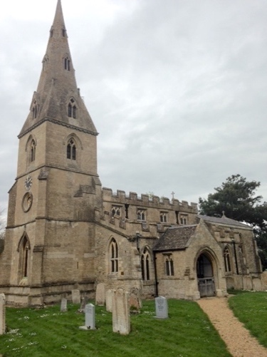
Our local project, recording St Peter's, Aldwincle, is in its last stage of compiling and checking prior to its acceptance, after audit, as a good record. Our compilers, Michael and Margaret Daking and I, were meeting regularly to move things on until . . . lockdown! We hope we will have a completed record by the end of the year.
Nationally, church recording in The Arts Society was dealt a heavy blow just before the pandemic struck. Following a Volunteering Impact Review by the national Society, in consultation with the receiving bodies of the National Archive including the V&A, church records will no longer be added to the Archive and financial support from the national Society to local groups will be withdrawn. The decision was taken ‘due to lack of evidence of public benefit and to very low usage of church records by the archival bodies keeping them’.
Not surprisingly, this news was received with shock and, it has to be said, anger by those societies for whom church recording has been a central part of their volunteering effort.
Members who wish to find out more should consult The Arts Society website. In the meantime, a group formed from leading church recording practitioners is reviewing its future with a view to simplifying the recording process, to make it more accessible and, in short, to keep it going. This will be outside the auspices of The Arts Society, but available to members and non-members alike. Church recording will continue and we wish it well.
We have no plans to start a new group at the moment ourselves, but when things eventually get back to normal it will be ‘on the table’.

Trails of Discovery – Nigel Harper
The former Church Trails volunteer section has a new title – ‘Trails of Discovery’ – reflecting the various trails that can be put together, eg for children, adults, and people with sensory deprivation.
We are delighted that Chris Cooke agreed to take on the role of Trails Coordinator last autumn. The trail at St Leonard's, Apethorpe, started and nearly finished by our previous coordinator, Sandra McAdam, will be completed by Chris with help from Area Coordinator Gill Murphy once we get back to pre-virus normality. Hopefully it will not be long before we are looking to start developing a new trail.

